# PROSPECTUS



**Our vision**.

* Giving children the wish to learn

**Our legacy.**

* Stimulated and Taught each child.
* Listened, Understood, Knew them. Had high Expectations of them & were Sharply focussed on their individual needs.
* Parents’ input & Reflection on our practice, lead to Excellent education & care.
* Safe, Caring, Healthy setting, achieving the best Outcomes. That’s Our Legacy.

#### Contents

##### Welcome from the Manager - page 3

Pre-School Aims - page 3

General Information - page 4

Session Times - page 4

Term Dates - page 4

Bad Weather Policy - page 4

Staff Details - page 5

Facilities - page 6

Security - page 7

Events - page 7

Admissions and Settling In - page 7

Curriculum - page 8

A typical Monday morning session - page 9

Payments - page 9

Children’s Belongings - page 10

Healthy Ethos - page 10

Accidents & Illness - page 10

Complaints - page 11

Partnership with Parents, incl. committee - pages 11-12

Testimonials - page 13

Comments from Parents/Carers - page 14

**St. Luke’s Pre-School (Rochester)**

**Wesley Hall, St. Luke’s Church**

**City Way**

**Rochester, ME1 2BQ**

**Tel: 01634 819809**

**email: office@stlukespre-school.co.uk**

[**www.stlukespre-school.co.uk**](http://www.stlukespre-school.co.uk)



**Welcome from the Manager**

I am sure you have many questions about entrusting the care and education of your child with us. I hope the following pages give you a glimpse of life at St. Luke’s.

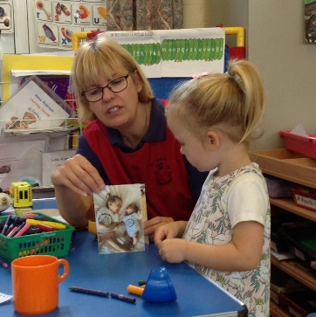The members of staff are a dedicated team, experienced and qualified in settling-in children in the transition from home to pre-school. Since 1966 the pre-school has been giving children the wish to learn and we know you and your child will enjoy your time with us.

Mrs Wendy Perkins

### Pre-School Aims

We aim to achieve our vision and legacy by:

* providing high quality care and education for the children
* providing a safe, stimulating and challenging learning environment which includes The Early Years Foundation Stage (EYFS) framework 2021.
* creating a friendly and supportive atmosphere where children, their families and the staff feel valued and happy.
* working in partnership with parents to encourage the children to learn and develop.
* adding to the life of the local community.
* promoting equality and valuing diversity.
* ensuring there is a firm foundation for continuous improvement and lifelong learning for all.
* use of a key worker system with continuity of care to enable observation of children’s needs and progress on an individual basis.
* working with agencies to meet children’s specific needs: speech and language therapists, paediatricians etc.
* Making ice-cream
  providing staff with development opportunities and recognising this as an integral part of continuous pre-school improvement.

Making ice-cream

### General Information

* St. Luke’s is a registered pre-school, run by a managing committee. It has sessional status, catering for children 2 – 5 years of age.
* A ‘Parent Information’ folder, along with books, magazines, leaflets, posters, and notices (including notices of our ‘Confidentiality,’ ‘Complaints‘ and ‘Safeguarding’ policies and procedures) are available in the entrance lobby. All our ‘Policies and Procedures’ and Ofsted inspection reports are available on request.
* We aim to provide a safe environment for the education and care of children and one way of achieving this is through our ‘Child Protection Policy and Procedures.’
* Please be assured that any information you share with us is completely confidential and will never be discussed with any other party without your prior knowledge and consent. See our ‘Confidentiality Policy.’
* We welcome children who still need nappies/pull-ups. Unfortunately, we have no facility to dispose of them so please do check your child’s bag.

**Session Times**



MON, TUES, WED & FRI 9.15am - 3pm

THURS 9.15am – 1pm

Term Dates

We are open 38/39 weeks of the year, in line with the usual local primary school term dates.

**Bad Weather Policy**

In the event of adverse weather, the pre-school will endeavour to remain open during normal pre-school hours.

However, it will be left to the discretion of parents to decide if it is safe for them to make the journey into pre-school or not.

If it is necessary to close the pre-school, for health and safety reasons, a message will be postedon our website [www.stlukespre-school.co.uk](http://www.stlukespre-school.co.uk) and telephone 01634 819809 and on Facebook.

Staff Details

|  |  |  |  |
| --- | --- | --- | --- |
|  | Wendy Perkins  Manager & DSL |  | Nicola Hill  Deputy Manager & SENCo |
|  | Pal Bains  Early Years Teacher |  | Tracie Bell  Assistant |
|  | Claire Fuller  Assistant |  | Lindsey Lloyd  Assistant |
|  | Hannah Page  Assistant |  | Maria Hill  Executive Advisor & former Manager |
|  | Victoria Trevallion  Administrator |  | Kirsty Sartain  Finance Officer |

Facilities

Great care is taken to provide a safe secure and stimulating environment which will allow your child to develop confidence, independence, and good social skills in what will become their second home. And so, as well as the main hall, where we role play, dance, sing, paint, read, construct … a kitchen to cook the pizzas and cookies made by the children, and low-level toilets, we …

use the church for our Christmas and Easter productions

use the grass area for obstacle courses and lots more

A group of kids sitting around a table

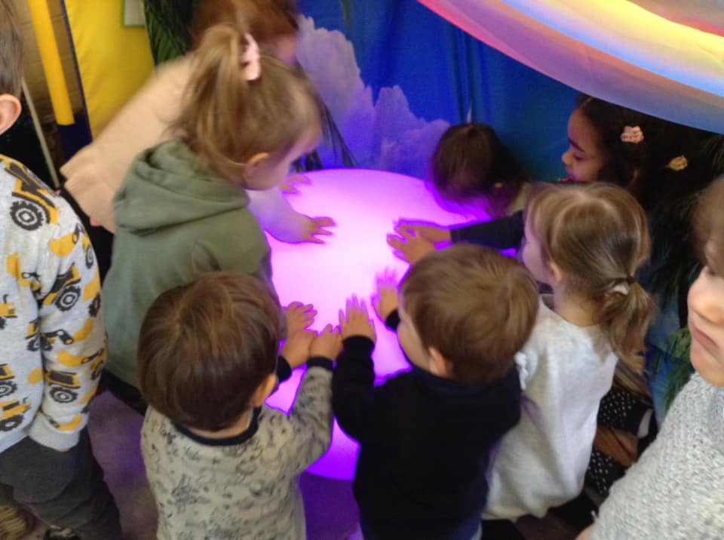use the back hall for parachute games

take selfies on iPads, play with the interactive light box … and all sorts of technological toys

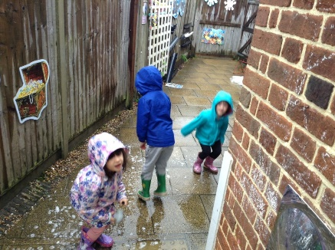

play on the bikes, on the swing … explore the sensory and fairy gardens, learn what happens when we pull this string …

**Security**

Our premises are completely secure during the sessions. Children are monitored on arrival and departure and only released to known adults.

### Password System

If you are unable to collect your child and know in advance who will, please write their name and contact details in the purple book, which is located in the entrance lobby. If it is an emergency, please ensure the person collecting your child knows your password so that the pre-school staff know this person has your permission. If you have a regular arrangement with a grandparent or childminder, a letter at the beginning of term will suffice.

Events

Drama productions Sponsored events & Sports Day

Breakfast with Santa Teddy Bears Picnic and Graduation

Christmas party Annual school photographs

Red Nose Day, Grandparents’ days … Outings

**Admissions and Settling-In**

Admission is in accordance with our Admissions Policy. It will be at the start of the first major term after your child’s 2nd birthday (children cannot be admitted before the age of two) subject to the availability of space.

Please visit at any time (by prior appointment) for an opportunity for you and your child to meet the staff and the child’s peer group, and to familiarise yourselves with the surroundings.

Please apply by completing and returning our ‘Registration Pack’, 6 weeks before the start of the term for which you wish your child to start. Our Registration Officer will telephone to confirm your child’s place. Parents must inform us if a place is no longer required.

To settle your child into pre-school, it may be necessary for you to remain for a short time as this is beneficial for all and a comfort to your child. We ask you to lead the settling in process: if you prefer to stay for part or all of the early sessions, we support you in this decision, and when you feel it is time to leave and allow your child to settle alone, we support you and your child in this. All children have different experiences and personalities when they start pre-school, and we understand that the parent/carer knows their child best.

Curriculum

We adhere to the Statutory Framework for the EYFS (2021) which sets the standards for learning, development, and care for children from birth to 5 years. The EYFS is based around four guiding principles:

1. A Unique Child - every child is a competent learner from birth who can be resilient, capable, confident, and self-assured.

2. Positive Relationships - children learn to be strong and independent from a base of loving and secure relationships with parents and/or a key person.

3. Enabling Environments - the environment plays a key role in supporting and extending children's development and learning.

4. Learning and Development - Children develop and learn in different ways and at different rates and all areas of Learning and Development are equally important and inter-connected.

The EYFS consists of seven interconnected areas of Learning and Development: three prime areas, Personal, Social and Emotional Development (PSED), Communication and Language (CL) and Physical Development (PD); and four specific areas namely, Literacy (L), Maths (M), Understanding the World (UW), and Expressive Arts and Design (EAD). Please see the posters or pack on view in the lobby or ask a member of staff for more information.

* We use ‘Signalong’, oral and gross motor exercises to aid speech and language development, which all the children really enjoy.
* We provide age-appropriate toys and activities that promote sharing and group play as well as developing each child’s individual skills and developing their social and physical skills by encouraging independence and freedom of choice.
* To enhance the curriculum, we often go offsite to various locations: the park, shop, small wood, post box or just for a walk to view the environment.
* We encourage visitors to the pre-school and links with the local community, including:

Police Service - road safety and stranger danger

Fire Service - dangers of matches and fire safety

Re-cycling - differing from waste to wormeries

Animal encounters - increasing confidence & new experiences

**A typical Monday morning session.**

9.15 – children enter and play freely inside.

9.30 – circle/registration time – formal register taken, St. Luke’s‘ welcome song’, birthdays celebrated, theme/topic (based on alphabet letter, book etc.) introduced/discussed.

9.45 – children are free to enjoy a variety of activities inside and in the sensory garden: drawing (on the large whiteboard outside or colouring in inside); constructing/creating (with lego and playdough inside or in the sand tray outside); dressing-up, role-play, quiet reading, whole group activities, including obstacle course, circle games, outdoor games etc.

11.45 – toileting/hands washed, ready for lunch.

12.15 - continue to enjoy a variety of activities.

1.00 - children leave with parent/carer.

Payments

* To add your child’s name to our waiting list, please let us know their name, date of birth and a contact number for yourself. Daily fees will be advised when you visit and also in a letter when your child starts.
* A deposit of £30 is payable when your child’s name is added to our waiting list. This will be refunded once your child starts at pre-school.
* Children are funded from the term after their 3rd birthday (cut off dates are 31st March, 31st August and 31st December). The funding is currently paid to the pre-school by Medway Early Years. A child is entitled to 15 hours each week for 38 weeks a year where available. We also accept 2 year working families funding and 30 hour funding.
* Payments are by BACs transactions or card. We also accept childcare vouchers.
* It is your responsibility to inform us if your child will be absent. All fees are still due during sickness, holiday and for any other absence. Special circumstances, such as prolonged illness or admission to hospital, should be referred to the Manager for discussion.
* 6 weeks written notice must be given for the permanent cancellation of a session or removal of a child from pre-school for any reason. Failure to provide such notification may incur payment of 6 week’s fees.

**Children’s Belongings**

* We request that your child does not wear his/her best clothing to pre-school, painting overalls are provided but accidents can still happen.
* The pre-school has its own design of sweatshirts, t-shirts, fleece jackets, bags and water bottles which are on sale throughout the term.
* Children should not bring sweets or wear jewellery to pre-school.
* Please could you ensure that you label ALL your child’s belongings to avoid any confusion. This includes any toys etc that the children bring into the pre-school.

#### Healthy Ethos

* A group of children dancing

  Description automatically generated with low confidenceWe encourage children in healthy eating and to take regular exercise, through the curriculum.
* Water and a choice of snacks are available for the children to access throughout the session. Fruit and vegetables are supplied at snack-time but donations (apples, grapes, bananas etc) are gratefully received.
* Children are also encouraged to pour their own drink of milk or water, butter their own toast … under adult supervision.

### Accidents and Sickness

* In the unlikely event your child may suffer an accident, we will try to inform you immediately and notify you of any further action that may be necessary. Any minor bumps, grazes etc will be reported in the Accident Book, which must be signed by the person collecting the child.
* If your child is sick, please **do not** allow them to return to the pre-school for **at least 48 hours** after the **last** bout of sickness.
* If your child has conjunctivitis, please ensure your child does **not** attend pre-school until the condition has cleared up, as it is contagious.
* Please inform the pre-school if your child has any contagious or infectious illness as soon as possible.
* As head lice is a continuing problem, please be vigilant and check your child’s hair regularly and inform the pre-school if you discover any ‘visitors’.

**Incubation and Exclusion Periods of the Common Infectious Diseases**

|  |  |  |  |  |
| --- | --- | --- | --- | --- |
| **DISEASE** | **SIGNS & SYMPTOMS** | **USUAL INCUBATION PERIOD** | **INTERVAL BETWEEN ONSET OF ILLNESS & APPEARANCE OF RASH** | **MINIMUM PERIOD OF EXCLUSION** |
| **CHICKEN POX** | Slight fever & irritating rash | 10-21 days | 0-2 days | 7 days from appearance of rash, all scabs need not have separated |
| **DIARRHOEA & VOMITING** |  | 1-7 days |  | Until 48 hours after cessation of diarrhoea/vomiting |
| **FOOD POISONING** | Vomiting, diarrhoea & abdominal pain | 0-2 |  | Until declared fit |
| **GERMAN MEASLES** | Slight cold, sore throat slight fever, enlarged glands behind ears ,pains in small joints | 14-21 days | 0-2 days | Until clinical recovery |
| **INFECTIVE JAUNDICE** | Gradual onset of headache, loss of appetite, nausea, dark urine, pale putty colour faeces | 14-42 days |  | Until clinical recovery |
| **MEASLES** | Misery, high temperature, heavy cold with discharging eyes & nose ,later harsh cough & conjunctivitis | 7-21 days | 3-5 days | Until clinical recovery |
| **MENINGITIS** | Headache, fever, vomiting, stiff neck, joint pains ,drowsiness or confusion, dislike of bright lights, rash of red/purple spots | 2-10 |  | Until clinical recovery & bacterialogical examination is clear |
| **MUMPS** | Fever,headache,swelling of jaw in front of ears,difficulty opening mouth | 12-28 days |  | Until all swelling disappeared |
| **SCARLET FEVER** | Sudden onset of fever,sore throat, vomiting, ’strawberry’ tongue, flushed cheeks, pallor around mouth | 2-5 days | 1-2 days | Until clinical recovery |
| **WHOOPING COUGH** | Acute respiratory catarrh, paroxysms of coughing | 5-14 days |  | Until clinical recovery |
| **HAND/FOOT MOUTH DISEASE** | Small blisters in these areas | 7-10 days to end of attack |  | From onset of blisters until all scabs cleared |
| **IMPETIGO** | Yellow oozing sores with scab on, itching usually around nose & mouth |  |  | Until spots have healed unless lesions can be covered |
| **HEAD LICE** | Head scratching, presence of eggs (white specks) stuck on hair, presence of lice |  |  | Until treatment has been carried out succesfully |
| **VERRUCAE** | Small solid growths on feet |  |  | Exclusion from barefoot activities until certified free from infection |
| **RINGWORM OF SCALP OR BODY** | Circular red raised area with white scaly centre, itching (if on scalp hair breaks off) |  |  | Until adequate treatment instituted, provided lesions are covered |
| **THREADWORM** | Presence of threadworms in stool (white cotton like pieces), sore anus, itching bottom, sleeplessness, lack of appetite |  |  | Until adequate treatment instituted |
| **SCABIES** | Burrows visible as red raised spots especially between fingers, intense irritation, sleeplessness |  |  | Until adequate treatment instituted |

**If in doubt, you are advised to consult your GP or health visitor.**

### Complaints

### The pre-school tries to operate in an informal and friendly manner. There are many opportunities for discussion of any issues. We hope that parents/carers will find they can easily talk to any member of staff to sort out any queries or difficulties before they escalate and become major issues or causes for complaint. See our ‘Complaints Procedure.’

Partnership with Parents

Working in partnership means, parents/carers and the pre-school both working together and sharing the care and upbringing of the child, which means sharing information about the child (either by having the parent physically there (on the rota or on the committee) or liaising with them (just a chat with a member of staff for example) to be able to make decisions about the child.

* **Daily Notices will be displayed on the window in the entrance lobby** including the ‘Parent Rota’, a copy of the latest letter/note and the latest ‘Newsletter’. We will also display the week’s theme/alphabet letter and any planned visitors for that week.
* **Committee** - The pre-school has a flourishing Parent and Teacher Association/Committee that works in close partnership with the pre-school. It provides support through its fund-raising activities as well as providing an important link between home and pre-school.

The committee has three principal roles: raising funds for new equipment and experiences; hosting events for the children such as the Christmas Shop and Summer Fete; and offering all parents the chance to be part of an inclusive pre-school community.

Anyone can be a member of the committee, whether you are a parent or grandparent. It is a chance to get involved with your pre-school community and enjoy some of the events and activities on offer.

“The generosity of the time donated by our committee members is astonishing and invaluable to the running of the pre-school”

Committee members arrange a host of activities and functions across the pre-school and play a vital role in raising funds for the pre-school, to provide those ‘icing on the cake’ extras, which often make learning more exciting and rewarding. The work of the committee in recent years has enabled the pre-school to extend the garden play area and provide outside play equipment, purchase a new large indoor mat and invest in a set of new iPads, as well as purchasing many other items such as soft play resources.

The committee meets monthly and has an Annual General Meeting in the Autumn Term. It welcomes new members who bring fresh ideas and approaches. Any help contributed to support its events ultimately, and most importantly, benefits every child at St. Luke’s Pre-School. For further details please speak to Vicky in the office.

* Parents with English as a second language are encouraged to come into pre-school to read to the children in their language which is enjoyed by all, especially their child.
* We produce a **newsletter** to keep you updated on events, dates etc. Contributions from parents are welcome and appreciated: recipes, craft ideas, poems etc.
* **The Parent Rota** on the lobby window has dates for parents, grandparents, aunts, uncles or carers to volunteer to help out in pre-school. It’s a great way to see what your child does at pre-school. However, we must point out that you should **not** bring another child or sibling with you, as he/she will **not** be covered by the pre-school’s insurance. Past experiences have shown that it is an ideal time to be able to give your child quality time without sibling(s) and you are an asset to the session.
* There will be opportunities throughout the year for you to discuss your child’s progress. We pride ourselves in our friendly approach to parents and are here to help in any matter if we can and have an open-door policy for you to see your child’s key worker at any time.

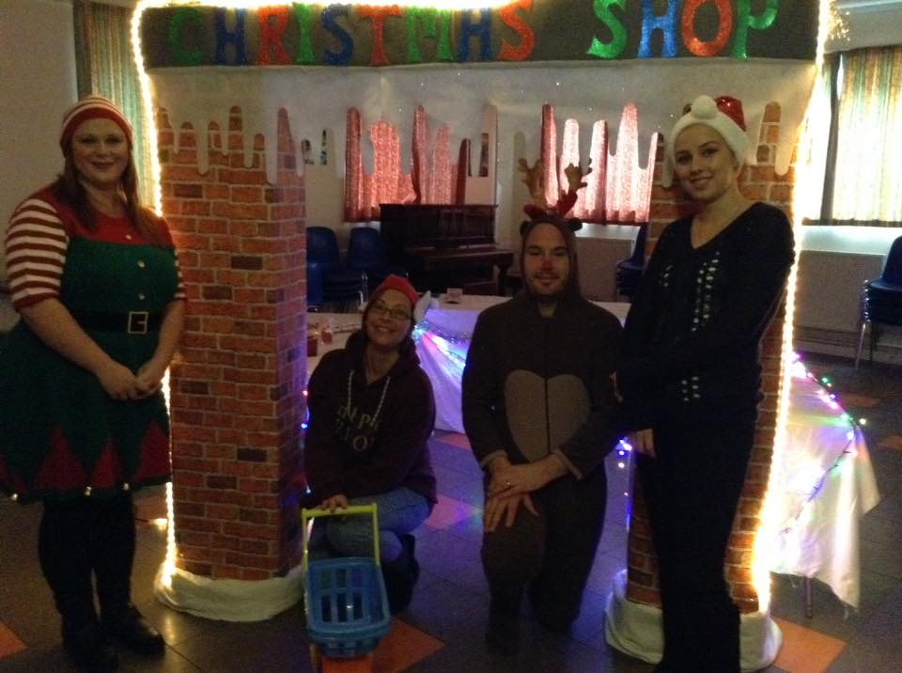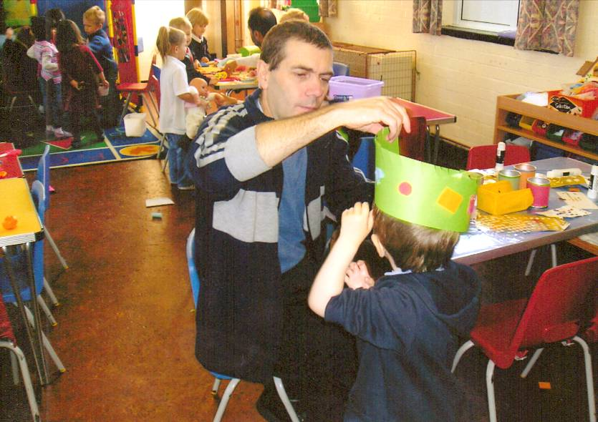

Committee members run the Christmas shop

A dad on the parent-rota

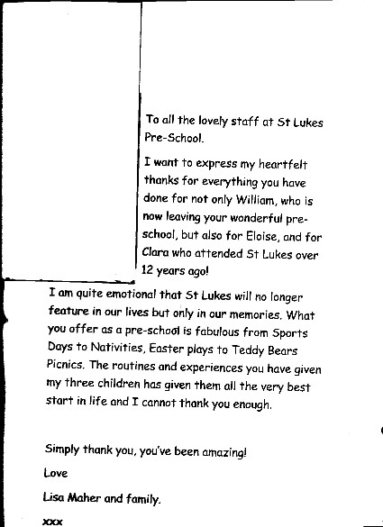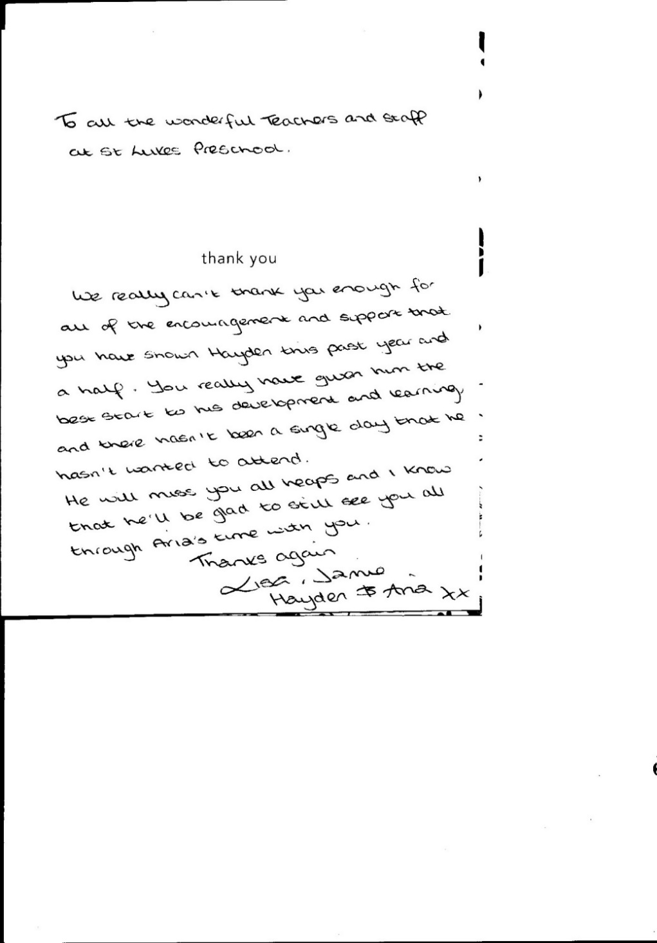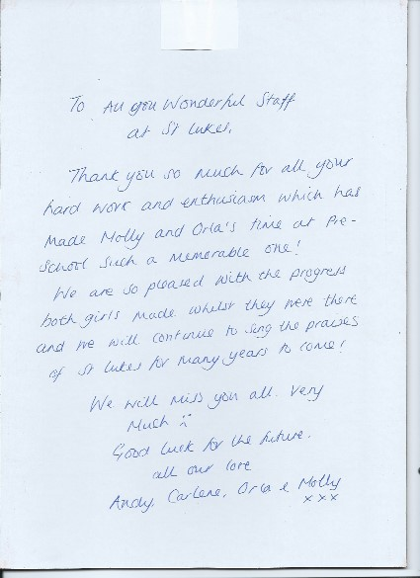Testimonials.

**Comments from Parents/Carers who attended on the Parent Rota.**

“I have had a great morning with some wonderful children. It’s great to have an insight as to what Phoebe does during her time at nursery.” Kelly Wright

“I thoroughly enjoyed my time at St. Luke’s today. It was good to get an insight into how Molly spends her day and get to know the other children she plays with. It was also good to see the staff team in action as well. I thought the way they interact with the children and the different techniques they use to promote a learning environment for the children was fantastic. Keep up the good work!” Andy Nixon

“Lovely session. I love St. Luke’s and think staff and children get along so well. Like a big family.” Dionne Webb

“St. Luke’s has a warm atmosphere, all staff are very approachable to children and staff alike. Bailey just loves his mornings here and was lovely to see him playing today.” Claire Robinson

“Enjoyed it thoroughly; staff well trained and work well as a team. Variety of activities, kids were never bored or ‘still’ at any time. Well done St. Luke’s.” Les Solomons