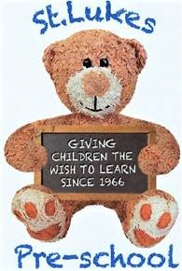 | St Lukes Pre-School  Term Dates – 2025-2026
Wednesday 3rd September 2025 – Autumn term begins – PM children (Thursday 4th ALL)
Tuesday 14th October – school photos
Monday 20th to Friday 24th October – half term break
Wednesday 3rd December – Dress rehearsal (am children)
Saturday 6th December – Breakfast with Santa
Wednesday 10th December – Christmas Play (am children)
Thursday 11th December – Christmas party and end of term
Friday 12th December – staff only

Monday 5th January 2026– Spring term begins – PM children (Tuesday 6th ALL)
Monday 16th to Friday 20th February – Half term break
Tuesday 24th March – Dress rehearsal (am children)
Tuesday 31st March – Spring Play
Thursday 2nd April – Spring term ends

Monday 20th April 2026– Summer term begins – PM children only (Tues 21st ALL)
Monday 4th May – May Bank Holiday – pre-school closed
Monday 25th May – Friday 29th May – half term break
Thursday 12th June – Sports Day (am children)
Thursday 9th July – Pre-school trip to Kent Life (leavers only)
Wednesday 15th July – Teddy Bear’s Picnic and end of term
Thursday 16th & Friday 17th July – stocktake – staff only

